**VEDANT KELKAR 1912052**

**CW**

data segment

n1h dw 1234h

n1l dw 5678h

n2h dw 1234h

n2l dw 5678h

prod dw 4 dup(0)

data ends

code segment

assume cs: code,ds:data

start: mov ax,data

mov ds,ax

mov cx,0

mov ax,n1l

mul n2l

mov prod,ax

mov prod+2,dx

mov ax,n1h

mul n2l

add prod+2,ax

adc prod+4,dx

mov ax,n2h

mul n1l

add prod+2,ax

adc prod+4,dx

jnc it4

inc cx

it4: mov ax,n1h

mul n2h

add prod+4,ax

adc dx,cx

add prod+6,dx

mov ah,4ch

int 21h

code ends

end start

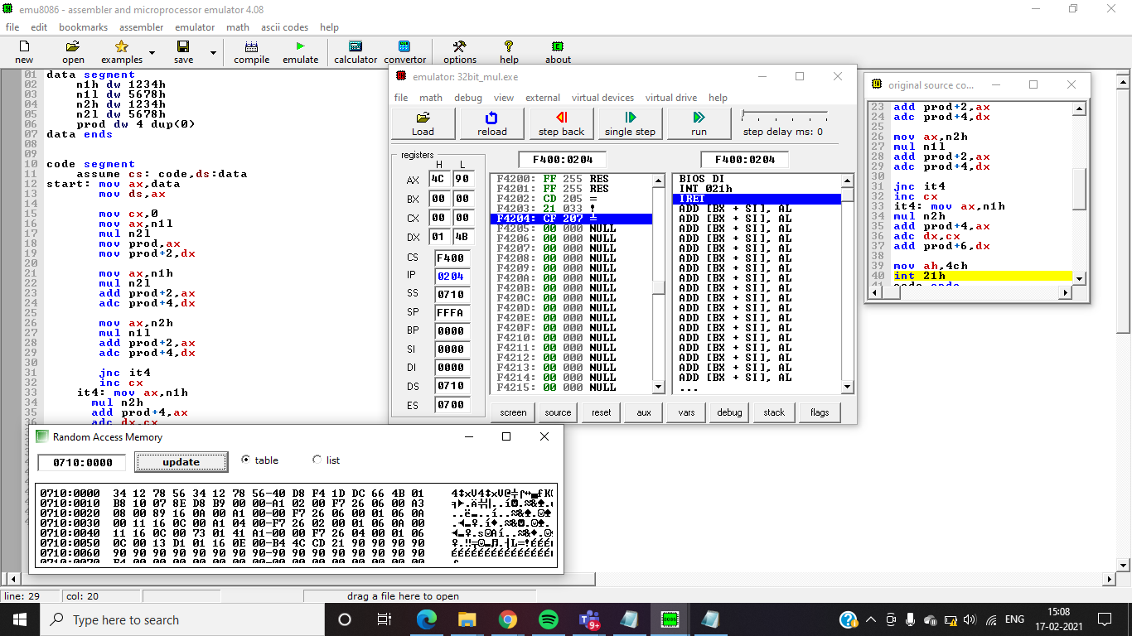

**HW**

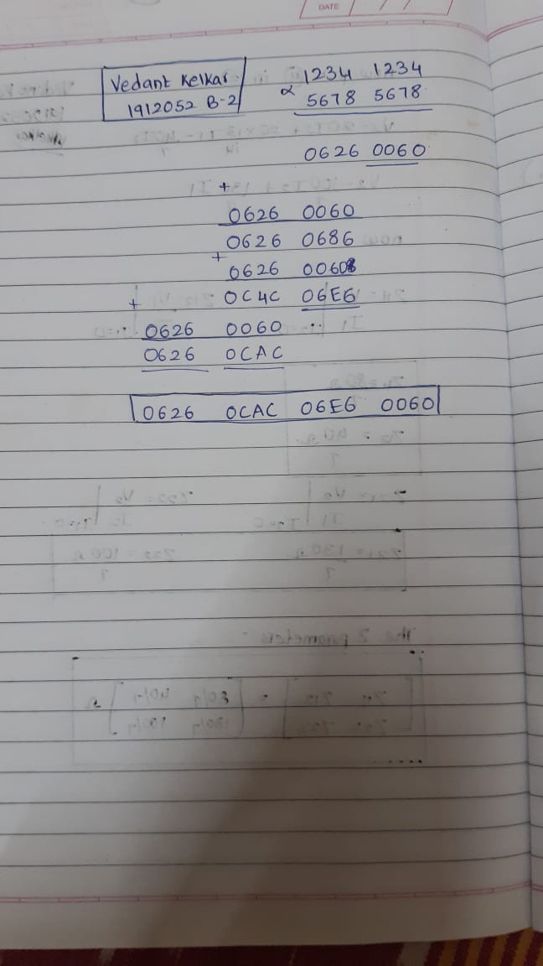

data segment

n1h dw 1234h

n1l dw 1234h

n2h dw 5678h

n2l dw 5678h

prod dw 4 dup(0)

data ends

code segment

assume cs: code,ds:data

start: mov ax,data

mov ds,ax

mov cx,0

mov ax,n1l

mul n2l

mov prod,ax

mov prod+2,dx

mov ax,n1h

mul n2l

add prod+2,ax

adc prod+4,dx

mov ax,n2h

mul n1l

add prod+2,ax

adc prod+4,dx

jnc it4

inc cx

it4: mov ax,n1h

mul n2h

add prod+4,ax

adc dx,cx

add prod+6,dx

mov ah,4ch

int 21h

code ends

end start

